**ACT1601: Fundamental of financial accounting**

Instructor: A. Issorasak Santivitoonvongs

อิศรศักดิ์ สันติวิฑูรวงศ์

Tips in learning this course.

* Pay attention especially for the first 3 chapters because it will create a strong basic knowledge for your best understanding.
* You have to practice the assignments assigned.

We shall have two quizzes. 1st Quiz before midterm, and 2nd quiz before final. Dates will be informed later.

**MARKS ALLOCATION:**

* Quiz I and Quiz II (3% + 3%) 6%
* Attendance + Assignments 4%
* Mid-term exam 40%
* Final exam 50%

# **TOTAL 100%**

**What is Accounting?**

The definition of accounting which was given by AICPA (American Institute of Certified Public Accountant)

Accounting is the language of business. Accounting is also an information system because it contains Input, process and output.

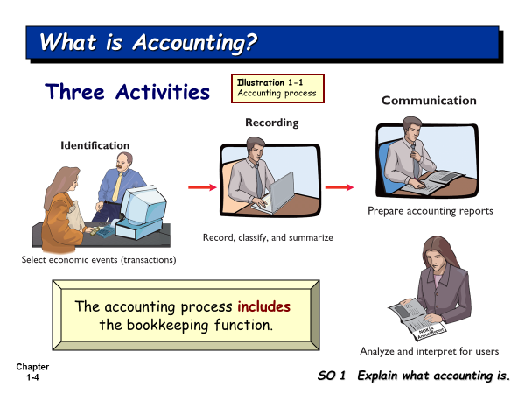

There are a lot of events occurred every day in the business. Some events are not economic events. The accountant will record only the economic events. So, accountants have to analyze the events whether the events are economic events or not.

Identification is the most difficult activity. If you do this activity mistake, other activities will be mistake too. This activity concerns about how we analyze the economic events before we go to Recording. Identification in Accounting here is select and analyze.

The output of accounting is the accounting reports which will be submitted to the interested users.

Accounting reports (Financial Statements) include

1. Income Statement
2. Retained Earnings Statement
3. Statement of financial position
4. Cash Flow Statement
5. Note disclosure

**Who uses the accounting data?**

There are internal users and external users.

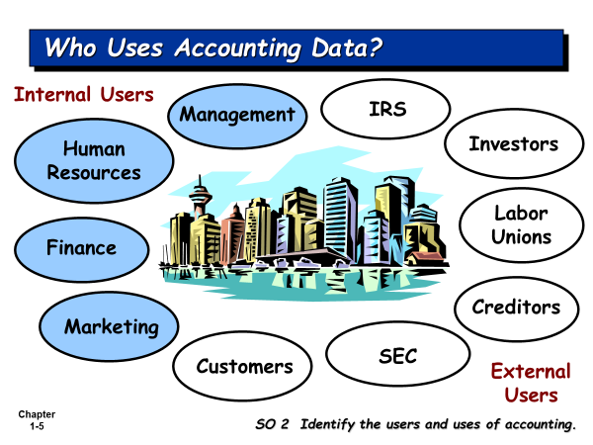

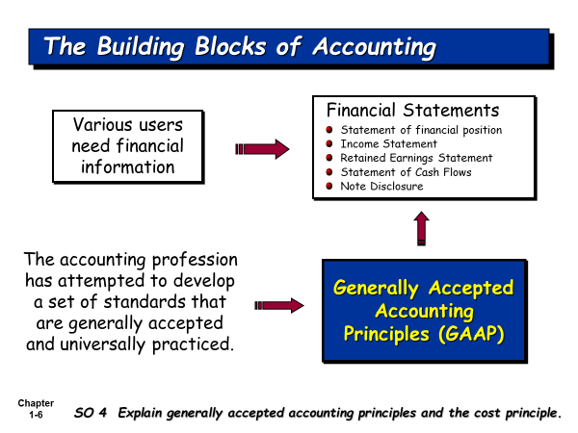

The financial statements are prepared based on GAAP.

**What is GAAP?**

**Generally Accepted Accounting Principles (GAAP)** is the standard framework of guidelines for [financial accounting](http://en.wikipedia.org/wiki/Financial_accounting). It includes the standards, conventions, and rules accountants follow in recording and summarizing transactions, and in the preparation of statements.

**Who developed GAAP?**

The accounting profession develops it.

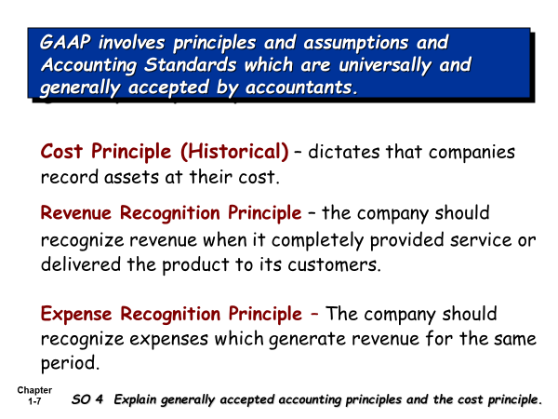

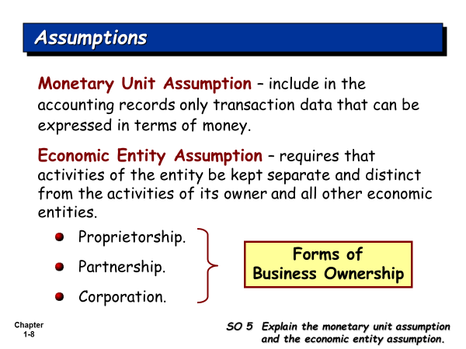

**Set up his company**

**Owner Organization (business firm)**

**Accountant** has to record the transactions for the business firm, not for the owner, because the accountant must hold the Economic Entity Assumption, that is, Owner and his business firm are the separate entity.

**Table 2.1 Some Accounting Concepts**

|  |  |
| --- | --- |
| **Basic Accounting Concepts** | **What It Means in Relationship to a Financial Statement** |
| **1. Separate Economic Entity Assumption** | Owner and his business firm are the separate entity. Shareholders are the separate entity from their company. |
| **2 Going Concern Assumption** | It is assumed that once the business firm is opened, the owner will run his business into the future quite long enough until he can meet his objectives. |
| **3. Monetary Unit Assumption** | An economic entity's accounting records include only quantifiable transactions. Accounting must be recorded using a stable currency e.g., the U.S. dollar, Thai Baht |
| **4. Time Period Assumption** | Most businesses exist for long periods of time (Going Concern Assumption). The accountant will artificially divide it into an equally time period, i.e., the company’s accounting period, which can be monthly, quarterly, and annually. We need to report the performance of our company under each accounting period. |
| **4. Historical Cost Principle** | **A**ssets are reported and presented at their original cost, e.g., our company bought equipment at 100,000 Baht, we record it at cost. |
| **5. Matching Principle (or Expense Recognition Principle)** | The matching principle requires that expenses incurred be matched with revenues generated from these expenses for an accounting period. |
| **6. Revenue Recognition Principle** | Revenue will be recognized (recorded) when our company’s service has been completed, or product has been delivered to customers, even money has not yet been collected. |
| **7. Full Disclosure Principle** | The full disclosure principle requires that financial statements include disclosure of information that is important to the users of the financial statements. It can be disclosed in the notes to the financial statement. |
| **9. Materiality** | Some expenses are very small, like taxi fare, stamps and so on, the accountant prefers to record them in one account, such as, Miscellaneous Expense. |
| **10. Conservatism Concept** | Under the uncertainty situation, the accountant will under-estimate the revenue and assets, and will over-estimate expenses and liabilities. |

1st act period (Jan 1- Dec 31)2nd act period (Jan 1, 2022 – Dec 31, 2022)

Jan 1, 2021 Dec 31,2021

I start my business on Jan 1, 2021. I will run my business quite long enough until I can meet my objectives. How can I measure the performance of my business firm? I want to know whether my business firm can make profit or not? We use the time period assumption to divide the life of our business firm into an equal time period. We call it Accounting period. The companies in Thailand have accounting period of 1 year.

Net Income = Revenues - Expenses

How do you record the revenues for the period? You will follow the Revenue Recognition Principle.

How do you record the expenses for the period? You will follow the Matching Principle (or Expense Recognition Principle).

**There are 3 forms of business ownership**

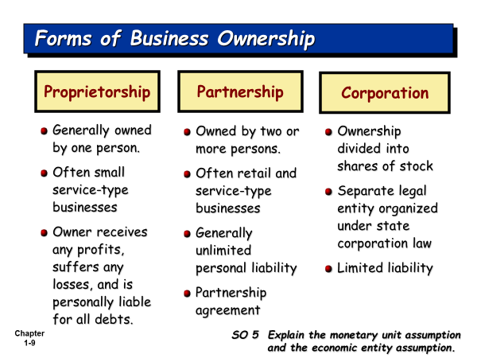

**Types of Business Operation**

1. Service business. The company sells the service (Complete/Provide service) to customers. Normally, this business is owned by one person, i.e., single proprietorship, e.g. Repair Shop, Barber shop, etc.
2. Manufacturing business. The company produces the products and sells the product to customers.
3. Merchandising business: The company buys the products, and then sells the product to customers.

**Fields of Accounting**

1. **Financial Accounting:** The accounting reports will be presented to the internal and external users
2. **Managerial or Cost Accounting:** The managerial accounting reports will be used by the managers of all levels for their planning, directing, and controlling of their operations.
3. **Tax determination and planning**
4. **Public Accounting/ or Independent audits**
5. **Data processing and information systems /or Accounting information systems**
6. **National income accounting**

**Accounting Profession/or accounting career paths**

1. Accountants and accounting Manager in the private firms
2. Certified Public Accountant (External Auditor): Many accounting students wants to work with the BIG4 Companies. The Big4 Companies are the international audit firms, like, PricewaterhouseCoopers, Ernst & Young, Deloitte Touche Tohmatsu, and KPMG.
3. Cost accountant and Cost Account Manager
4. Internal Auditor
5. Tax Planning Officer/ Tax Planning Manager
6. Accounting System/Information System Designer
7. Government Accountant
8. Business Consultants

There are two accounting bases: - Cash Basis Accounting and Accrual Basis Accounting.

**Cash Basis Accounting** is the accounting method that revenues are recognized only when the company receives cash, and expenses are recognized only when the company pays cash.

**Accrual Basis Accounting is** the accounting method that recognizes revenue when they are earned (Revenue Recognition Principle), even cash has not yet been received; and recognizes expenses when they are incurred, even cash has not yet been paid (Matching Principle). Accrual basis accounting is considered to be the standard accounting practice for most business companies in the market. GAAP recommends all business companies to use Accrual Basis of Accounting.

**Accounting Equation is the start of accounting recording.**

**What is the transaction?**

**Accountant must select** and analyze the transactions which have an impact on the Accounting Equation.

**Assets = Equities**

*Resources of the firm = Sources of the firm’s resources*

Assets are the resources of the firm. Equities are the source of the firm’s resources

**Assets = Equity of creditors (Liabilities) + Equity of owner**

*Resources of the firm Rights of creditors’ claims on the firm’s Rights of Owner’s claims resources on the firm’s resources*

How many forms of business ownership?

**Sole (Single) Proprietorship**

**Assets = Liabilities + Owner’s Equity**

**Partnership**

**Assets = Liabilities + Owners’ Equity**

**Corporation**

**Assets = Liabilities + Stockholders’ Equity**

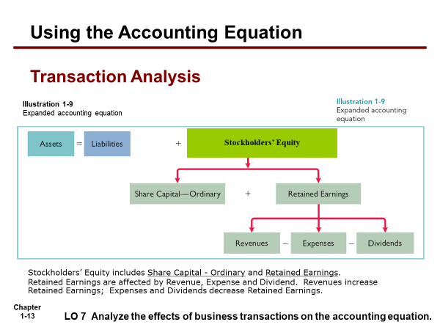

*Note: For intensive accounting, we focus on how to do the accounting record for single proprietorship; while the course Act1600 and Act 1601, we focus on how to do the accounting record for corporation.*

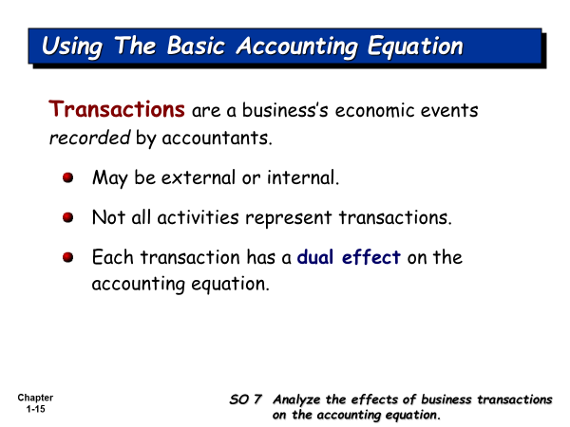

**We can apply accounting equation for your personal life recording.**

**Assets = Liabilities + Parents’ Equity**

**Assets = Claims of creditors (Liability) + Parent’s Claim**

Cash + Book + Calculator = Supplier’s Claim + Friend’s Claim + Mother Capital

+1,000 = +1,000

- 800 + 800 .

**Bal. 200 + 800 = +1,000**

- 200 + 1,000 = + 800 .

**Bal -0- + 800 + 1,000 = + 800 +1,000**

+500 = +500 .

**Bal +500 + 800 + 1,000 = +800 +500 +1,000**

- 400 = - 400 (Ent exp)

-100 = - 100 (food exp)

**Bal -0- + 800 + 1,000 = +800 +500 +500**

+2,000 = +2,000

**Bal +2,000 + 800 + 1,000 = +800 +500 +2,500**

- 800 = - 800

- 500 = -500 .

**Bal +700 + 800 + 1,000 = -0- -0- +2,500**

Assets are the resources which you own.

Liability and Parents’ Equity are the sources of your owned resources.

**Class no. 2 for Section 401 and 402 on 22/11/2022**

We are still in Chapter 1. What is the core topic in this chapter?

We are able to analyze the transactions on the accounting equation.

Accounting equation for Company:

Assets = Liabilities + Shareholders’ Equities

What is the transaction?

There are so many events occurred every day. Some events are not economic events (transactions). If they are the economic events, they have impact on the accounts in accounting equation. The accountant will record only the transactions in the book.

Today class, I will show you how we analyze the transactions on the accounting equation.

Chart of accounts is the list of account names and account numbers used by that company.

**Class no. 3 for section 401 and 402 on 29/11/2022**

Journalize the transactions: Record the transactions in the journal book.

The Journal book is the book of original entry.

Post to the ledger accounts: is the transferring of information recorded in the journal book into the ledger accounts.

Accounting Equation for Company:

How the accountant records the transactions in the Journal book

Trial Balance is the internal accounting report in order to check the balances of accounts on the specified date, and to check the total debit amount equal to the total credit amount or not.

Balance of asset accounts is always Debit, we call normal balance of asset accounts is Debit. Balance of liability accounts is always Credit. Balance of Share-Capital-Ordinary is always Credit. Balance of Dividend is always Debit. Balance of Revenue accounts is always Credit. Balance of Expense accounts is always Debit.

Record transactions in chronological order. Record Debit before credit.

In each transaction record, total debit amount equal to total credit amount, because we are under Double entry accounting.

Double entry accounting, there are simple entry and compound entry.

Simple entry: one debit and one credit; Compound entry: more than one debit or more than one credit.

Debit = Credit

Assets = Liabilities + Stockholders’ Equities

+ = + +

Decrease (-) = Decrease (-) Decrease (-)

**Class No 4 on Dec 6, 2021 for Section 401 and 402**

See the work from one student. Where is his mistake?

You can practice Problem 2-5, if Problem 2-2 and 2-4 have been done already.

Before I teach you another topic today, you should have understanding of how to journalize the transactions. I want you to review it within 30 minutes.

Here is the next topic. It is to test your understanding of journal entry in another dimension deeper.

**Correcting entry** is the journal entry to correct the error in your recording in the journal book which has been posted to the accounts.

In accounting, when the accountant finds his error in their recording, he can not correct **it without clue, he has to prepare correcting entry.**

*Example 1*

*Our company purchased supply for cash 57 Baht; but we erroneously recorded Dr. Supply and Cr. Cash 75 Baht*

*The incorrect entry:*

*Dr. Supply 75*

*Cr. Cash 75*

*Correcting entry:*

*Dr. Cash 18*

*Cr. Supplies 18*

*Example 2*

*Our company purchased supply for cash 57 Baht; but we erroneously recorded Dr. Supply Expense and Cr. Cash 57 Baht*

*The correct entry:*

*Dr. Supply 57*

*Cr. Cash 57*

*The incorrect entry:*

*Dr. Supply Expense 57*

*Cr. Cash 57*

*Correcting entry:*

*Dr. Supplies 57*

*Cr. Supplies Expense 57*

*Example 3*

*Our company purchased supply for cash 57 Baht; but we erroneously recorded Dr. Supply Expense and Cr. Cash 75 Baht*

*The correct entry:*

*Dr. Supply 57*

*Cr. Cash 57*

*The incorrect entry:*

*Dr. Supply Expense 75*

*Cr. Cash 75*

*Correcting entry:*

*Dr. Supply 57*

*Cash 18*

*Cr. Supply Expense 75*

Problem 4-1

1)

|  |  |  |
| --- | --- | --- |
| The correct entry | The incorrect entry (error) | Correcting entry |
| Dr. Cash 1,000  Cr. A/R 1,000 | Dr. Cash 700  Cr. Service Rev. 700 | Dr. Cash 300  Service Rev. 700  Cr. A/R 1.000 |

2)

|  |  |  |
| --- | --- | --- |
| The correct entry | The incorrect entry (error) | Correcting entry |
| Dr. Dividend 3,000  Cr. Cash 3,000 | Dr. Salaries and.. 3,000  Cr. Cash 3,000 | Dr. Dividend 3,000  Cr. Salaries. 3,000 |

*3)*

|  |  |  |
| --- | --- | --- |
| The correct entry | The incorrect entry (error) | Correcting entry |
| Dr. Cash 1,000  Cr. A/R 1,000 | Dr. Cash 2,000  Cr. A/R 2,000 | Dr. A/R 1,000  Cr. Cash 1,000 |

*4)*

|  |  |  |
| --- | --- | --- |
| The correct entry | The incorrect entry (error) | Correcting entry |
| Dr. Utility Exp 107  Cr. Cash 107 | Dr. Utility Exp 170  Cr. Cash 170 | Dr. Cash 63  Cr. Utility Exp. 63 |

*5)*

|  |  |  |
| --- | --- | --- |
| The correct entry | The incorrect entry (error) | Correcting entry |
| Dr. Cash 4,500  Cr. A/R 4,500 | Dr. Cash 4,500  Cr. A/P 4,500 | Dr. A/P 4,500  Cr. A/R 4,500 |

*6)*

|  |  |  |
| --- | --- | --- |
| The correct entry | The incorrect entry (error) | Correcting entry |
| Dr. Salary and.. 1,200  Cr. Cash 1,200 | Dr. Utilities Exp 1,200  Cr. Cash 1,200 | Dr. Salary and… 1,200  Cr. Utilities Exp 1,200 |

*7)*

|  |  |  |
| --- | --- | --- |
| The correct entry | The incorrect entry (error) | Correcting entry |
| Dr. Equipment 760  Cr. A/P 760 | Dr. Equipment 670  Cr. A/P 670 | Dr. Equipment 90  Cr. A/P 90 |

**Class no 5 for section 401 and 402 on 13/12/2022**

**Jan 1, 2022 Dec 31, 2022**

**Jan 1, 2023 Dec 31, 2023**

**Assume I start my business on Jan 1, 2022. I have my objective to run my business until I am 100 years old. So, my company is running into the future time quite long enough until I can meet my objective. How can I measure my company’s performance? What I want to know whether my company’s performance is good or not? I want to know my company can make a profit or not. You have to divide the time line into an equal time period (Time Period Assumption). Where the profit comes from? It comes from total revenue in the accounting period minus total expenses in the same period. How can you recognize the revenue in the period? We follow the Revenue Recognition Principle. How can you recognize the expense in the same period? We follow the matching principle. During the accounting time period, what works the accountant has to do? It starts from analyze transaction and business documents, journalize transactions, Post to ledger accounts. When it comes to the end of accounting period, the accountant has to prepare adjusting entries, closing entries, and prepare accounting reports.**

**Summary of the Accounting Cycle (or the repetitive works of accountant in each accounting time period)**

1. Analyze transactions and business documents.

2. Journalize transactions.

3. Post journal entries to Ledger accounts.

4. Determine account balances and prepare a trial balance, then the accountant can get the Unadjusted Trial Balance.

5. Journalize and post adjusting entries to the ledger accounts, then the accountant can get Adjusted Trial Balance

6. Prepare financial statements (Accounting reports).

7. Journalize and post the closing entries, then the accountant can get the post-closing trial balance. The post-closing trial balance will contain the accounts and their balances which will be carried forward to the next accounting year period.

Why we need to prepare adjusting entries at the end of each accounting time period?

Because some revenues and some expenses has not yet been recognized. If they are not recognized, the accountant will miss them, and their profit and loss will not be correct. Where the profit of the company comes from? It comes from Revenue minus ( - ) Expenses. For example, total revenue for the accounting time period (2022) is 100,000 Baht, total expenses for the same period are 80,000 Baht, the profit is 20,000 Baht. We found out that at the end of accounting period, there are some revenues (amounted to 2,000 Baht) has not yet been recognized. If you recognized it, the total revenues will be 102,000 Baht. And we found out that some expenses (amounted to 1,000 Baht) have not yet been recognized. If you recognize it, the total expenses will be 81,000 Baht. So, the correct profit will be 102,000 – 81,000 = 21,000 Baht.

There are 4 types of adjustment: Prepaid expense type, Unearned revenue type, Accrued Revenue type, and Accrued Expense type.

**Prepaid expense type of adjustment** is the prepaid expense which has first been recorded in the asset account, and then will be adjusted for the asset used (or consumed), which is the expenses for the period.

**Unearned revenue type of adjustment**: Cash has been received in advance for the service which has not yet been provided or completed and the accountant has first recorded it in the liability account. At the end of the accounting period the accountant will adjusted for the service which has been provided or completed, and recognize it as the earned revenue for the period.

**Accrued Revenue type of adjustment:** At the end of accounting period, the accountant finds out that some services have been completed for the period, but the accountant has not yet recorded or recognized them.

Or Accrued Revenue is the revenue which has been accrued for the period, but the accountant has not yet recognized it.

**Accrued Expense type of adjustment:** At the end of accounting period, the accountant finds out that some expenses have been incurred for the period, but the accountant has not yet recorded or recognized them.

**Class no. 6 on Dec 20, 2022**

**Continue about adjusting entry.**

**Problem 3-1 (9)**

**In 2017: Dr. Supplies 750**

**Cr. Cash / Accounts Payable 750**

**At year end: Dr. Supplies Expense 350**

**Cr. Supplies 350**

**Problem 3-1 (10)**

**Jan 1, 2017 Dr. Equipment xxx**

**Cr. Cash / Accounts Payable / Notes Payable xxx**

**At year end: Dr. Depreciation Expense xxx**

**Cr. Accumulated Depreciation - Equipment xxx**

**Asset account, its normal balance is Debit; but Accumulated Depreciation, its normal balance is Credit. So we call this account, Contra-asset account.**

**Today we learn how to find the amount of depreciation expense and Accumulated Depreciation in the real life. There are 3 depreciation methods.**

**1st method: Straight-line**

**2nd method: Units-of-activity**

**3rd method: Double Declining Balance**